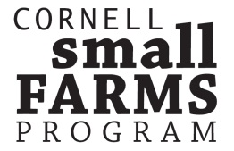 | (P) 607.255.9227 (F) 607.255.0599  smallfarmsprogram@cornell.edu  www.smallfarms.cornell.edu  15A Plant Science Building  Ithaca, NY 14853

2014 NY SMALL FARM STATEWIDE SURVEY RESULTS
Beyond Direct Marketing: Exploring New Ways to Sell
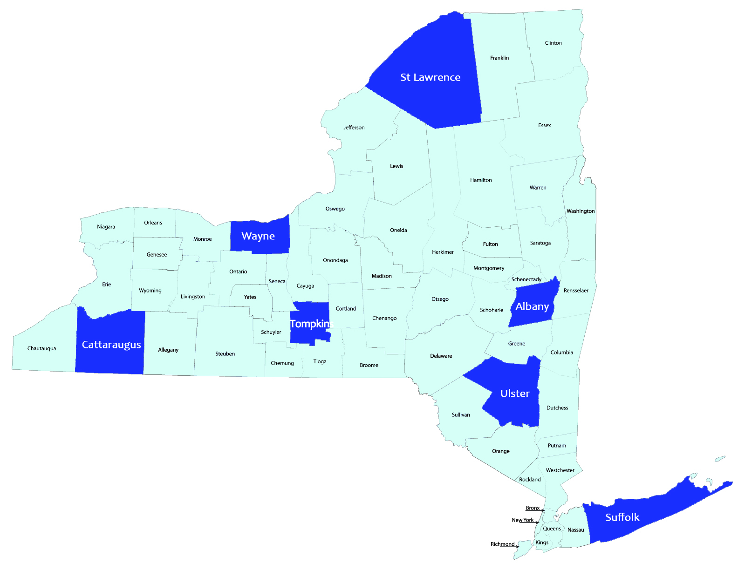
Prior to today’s Summit, we conducted a survey of NY farmers, to understand their current and future possible market channels. We asked each to tell us about their farm size, years of experience, income and primary enterprises as well as their levels of satisfaction with different channels. Here is of summary for responses from across the state.

Enterprises Listed in Top 3 | % of Responses
Vegetables | 19
Poultry | 13
Field Crops/Hay | 10
Beef | 9
Fruit- Trees/Berries | 8
Sheep & Goats | 7

Market Channels

Currently, direct marketing channels represented 80% of the strategy used to sell products. Farmer’s Markets and Farm Stands were most commonly used for direct marketing. Most important wholesale channels were restaurants and grocery stores.

82% of farmers expressed interest in new markets, over the next two years.

