Turning Milk to Gold (Butter)
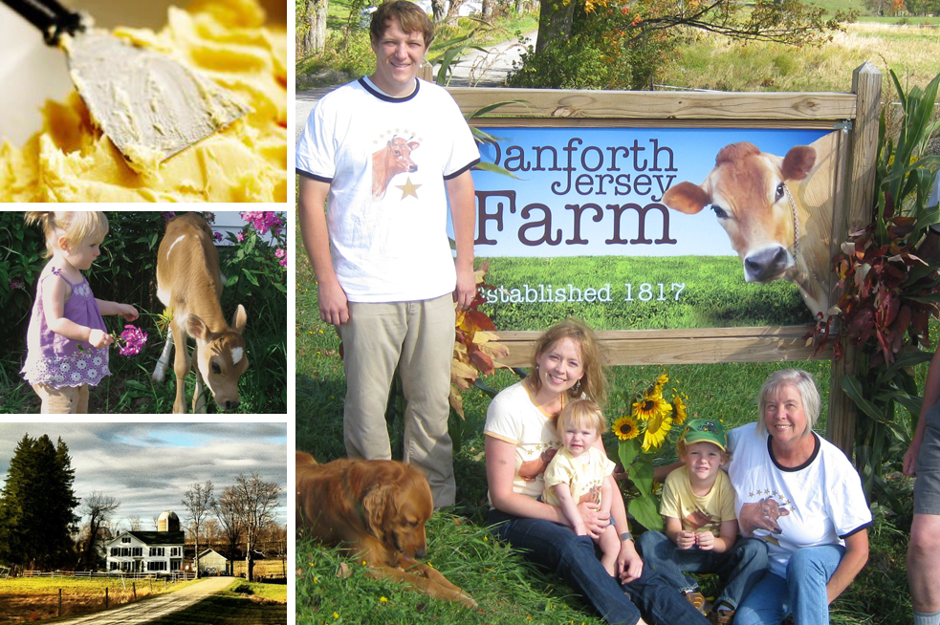
Cowbella, Danforth Jersey Farm in Jefferson, NY
Since 1817, Shannon Mason’s family has operated Danforth Jersey Farm in the Catskills region of upstate NY. Mason, the sixth generation to grow up on the farm, returned to the family business in 2006 and launched Cowbella yogurt and butter products in 2010.

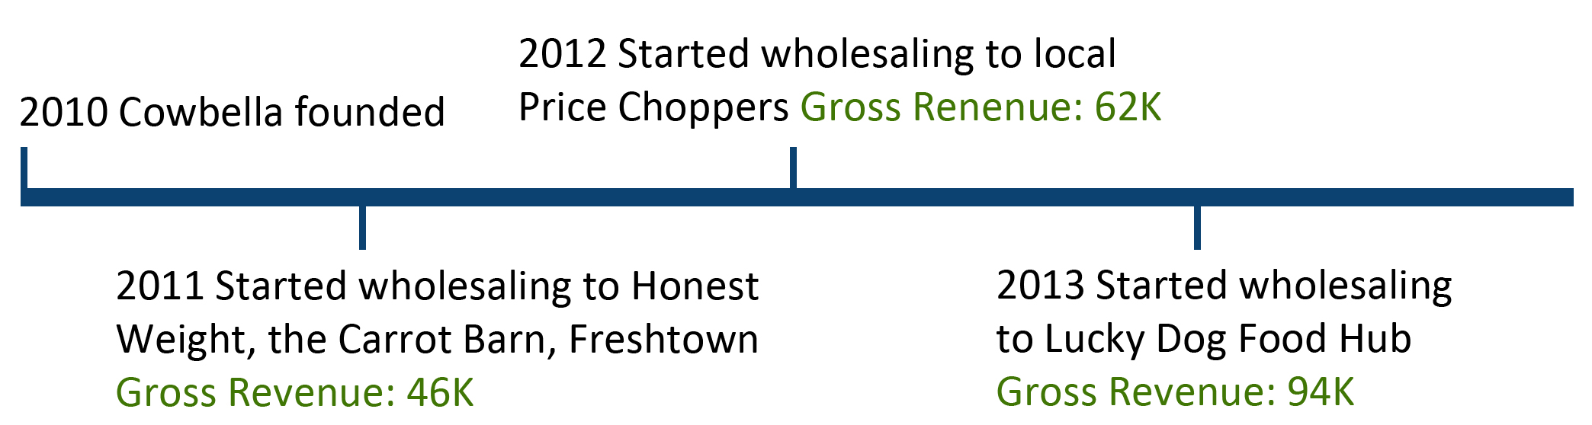
Historically, Danforth Jersey Farm sold all of their liquid milk for shipping on the milk truck, but Mason is working to diversify that model. In 2013, 15% of the farm’s milk was diverted from the milk truck to Cowbella products, all of which are processed on-farm, and Mason’s long-term goal is to use their entire dairy for value-added Cowbella products. When Cowbella got its start in 2010, its products were sold primarily in specialty grocery stores in upstate NY, at Farmer’s Markets, and on-farm. Cowbella’s market mix began to shift in early 2011 by wholesaling to Honest Weight Food Cooperative in Albany, Freshtown grocery in Margaretville, the Carrot Barn in Schoharie, and in 2012 local Price Chopper groceries. Mason’s most recent wholesale market is Lucky Dog Local Food Hub based in Hamden, NY. Lucky Dog connects NYC buyers to upstate NY products and specifically works with small-to-mid size farms. Lucky Dog Farm is an organic vegetable farm begun in 2000 by two farmers who transported their vegetables to regional markets in a refrigerated truck that had more room than their own vegetables could fill – so they opened up the space to fellow upstate NY farmers wanting to reach new markets. Lucky Dog Local Food Hub works in partnership with the Center for Agricultural Development and Entrepreneurship (CADE) to connect with last-mile distributors and buyers in the NYC area. The charge for their delivery service is 15% of gross product value.
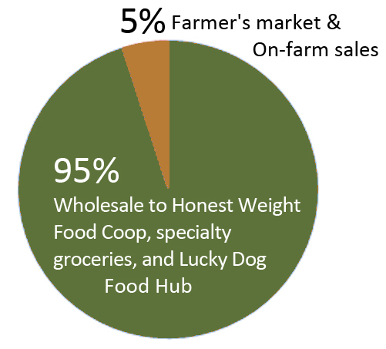
A wholesale-dominant market mix – now representing about 95% of Cowbella’s sales -- has allowed Mason to expand Cowbella product offerings to include a kefir drinkable yogurt, as well as justifying the purchase of a filling machine that speeds up the packaging of fluid milk and yogurt. Additionally, the farm is now producing enough volume that she is able to purchase pre-printed yogurt containers, eliminating the time consuming task of adding stickers to yogurt containers by hand. In the past year, Mason has implemented a rotational grazing program across the farm’s 310 acres (some of which is corn for hay as well as forested area), replacing the free range open-pasture model the farm previously used. In addition to improving pasture health, rotational grazing allows Mason’s 40 milking head herd to enjoy a longer grazing season and more nutritious grasses. She said the change in feed quality is visible in the butter produced – when Jersey cows are eating high quality grass, the butter made from their milk is “a very rich, bright, sunflower yellow.”
Current Marketing Channels

Mason is a member of a group of value-added dairy producers in the Delaware and Schoharie County areas called Catskills Family Creamery. The producer group has provided Mason with an important network of local farmers from whom she can source specialty produce, such as fruit or nuts, for use in yogurt and other Cowbella products. The 8 value-added dairy producers meet once a month to discuss issues and plan events, last year holding a field day called “Travel the Milky Way”, establishing their farms as a kind of dairy trail open to the public for visiting and learning about how NY dairy products are made.

