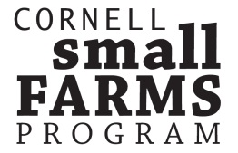 | (P) 607.255.9227 (F) 607.255.0599  smallfarmsprogram@cornell.edu  www.smallfarms.cornell.edu  15A Plant Science Building  Ithaca, NY 14853
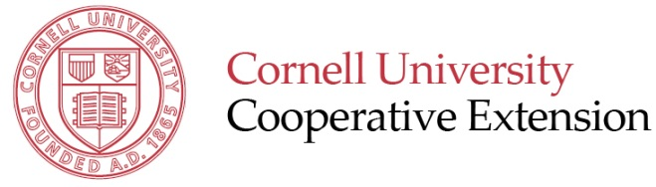

2014 NY SMALL FARM SUMMIT
Beyond Direct Marketing: Exploring New Ways to Sell

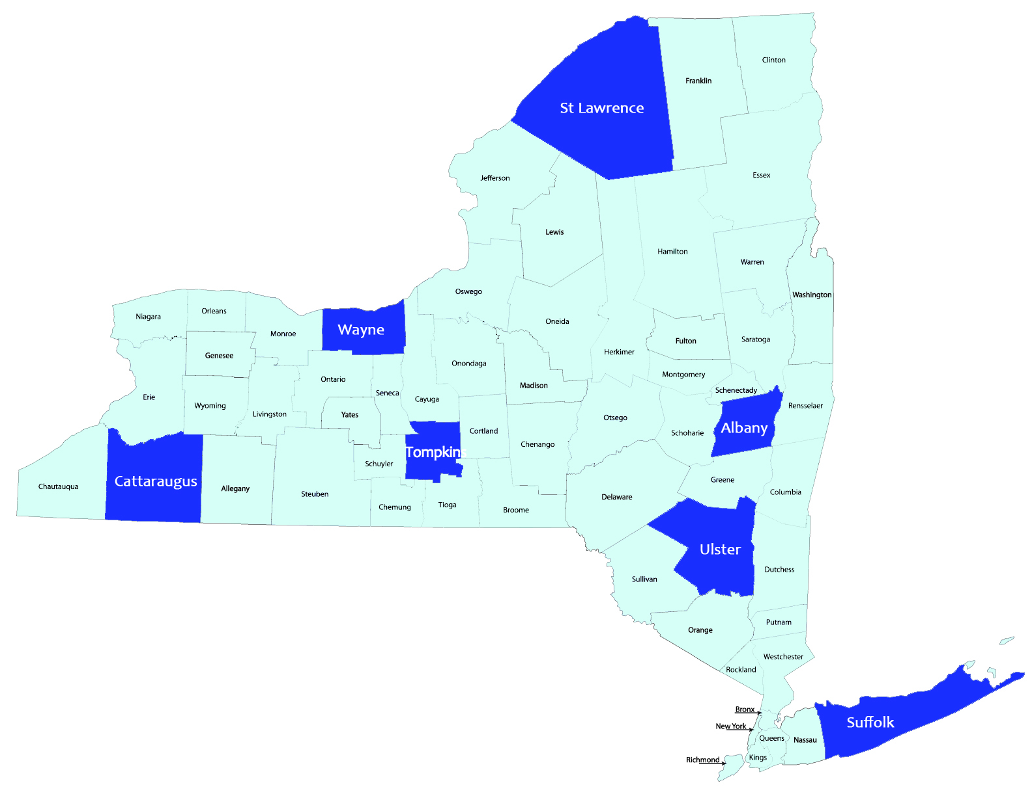
General Schedule

State-Wide Video Conference

9:00 AM Arrive, Registration, Refreshments

9:30 AM Welcome - Anu Rangarajan, Director of the Cornell Small Farms Program

9:45 AM Darren Maum - Salvere Farm in Marietta, NY (Onondaga County)

10:30 AM Shannon Mason - Cowbella in Jefferson, NY (Schoharie County)
Regional Host Sites

Finger Lakes: Wayne County CCE, Newark, NY
Central NY: Cornell University Campus, Ithaca, NY
Eastern NY: Albany County CCE, Voorheesville, NY
Hudson Valley: Ulster County CCE, Kingston, NY
Northern NY: St. Lawrence County CCE, Canton, NY
Western NY: Cattaraugus County CCE, Ellicottville, NY
Long Island: Suffolk County CCE, Riverhead, NY

11:15 AM Stephen Winkler - Lucki7 Livestock Co. in Rodman, NY (Jefferson County)

12:00 PM Discussion

Regional Host Site Program

12:30 PM Lunch

1:30 PM Identifying Local Wholesale Markets

2:00 PM Group Discussion: Exploring Wholesale Markets and Action Planning

3:15 PM Closing and Evaluation

3:30 PM Adjourn

