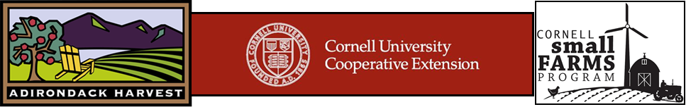
Promoting Workplace CSA’s in the Southern Adirondacks

Contacts:
Laura McDermott Teresa Whalen
CCE CDVSFP Adirondack Harvest, Southern Chapter Coordinator
Hudson Falls, NY Warrensburg, NY
518-746-2562 518-466-5497
lgm4@cornell.edu taawhalen@yahoo.com

What is a CSA? Community Supported Agriculture (CSA) is one way for consumers to gain access to locally grown food direct from the farmer. When CSA’s were originally developed almost 2 decades ago, they provided a market for produce and a way for farmers to share the “ethos” of farming with interested consumers. The farmers gained much needed capital at the beginning of the growing season, and consumers were provided fresh, locally grown produce each week. CSA’s vary greatly in terms of distribution, cost, consumer involvement at the farm etc.
How do CSA’s work? A farmer offers a certain number of "shares" to the public. Typically the share consists of a box of vegetables, but other farm products like fruit, eggs, dairy and even meat may be included. Interested consumers purchase a share (or subscription) and in return receive a delivery of seasonal produce each week throughout the farming season. Deliveries are made to designated locations at consistent times.
Benefits to Consumers:
- Purchase food usually harvested within 24 hours of delivery, with increased flavor and vitamins
- Get exposed to new vegetables and new ways of cooking
- Usually consumers are encouraged to visit the farm at least once a season – you get to see how and where your food is grown – a benefit in times of food safety concerns
- Children favor food from "their" farm – even veggies they've never been known to eat
- Develop a relationship with the farmer who is often a part of the community
- Members may expenses decrease - the food compels them to use it – thus eating out less and consuming more fresh produce
Benefits to farmers:
- Get to spend time marketing the food early in the year, before field season begins
- Receive payment early in the season, which helps with cash flow
- Have an opportunity to get to know the people who eat the food they grow

Shared Risk
Shared risk is an important concept of the CSA model. Some CSA farms stress this more than others, and CSA members may be asked to sign a policy form indicating that they agree to accept certain conditions without complaint. Most CSA farmers feel a great sense of responsibility to their members, and when crops are scarce, they prioritize the CSA shareholders. Still, things occasionally are out of the farmers’ control – case in point, Hurricane Irene and Lee. Many local farms suffered extensive losses and some CSA shareholders received shares that were less than they had expected. Fortunately these types of natural disasters are infrequent.
Statistics:
- Tens of thousands of families have joined CSA’s nationwide
- Currently, there is more demand for CSA’s than there are farmers
- 2007 USDA data indicates that there are 12,549 farms in the US marketing through a CSA model – 364 of them are in NYS
- There are many variations of CSA’s including “market style”, food bank models, specific commodity shares, (i.e. fruit, bakery, eggs, meat, dairy etc.)
- Non-farming third parties are setting up CSA-like businesses, where they act as middle men and sell boxes of local (and sometimes non-local) food to their members
- Most supermarket produce is picked 4 to 7 days before being placed on grocery shelves, and is shipped for an average of 1500 miles
- Only 18 cents of every dollar, when buying at a large supermarket, go to the grower. 82 cents go to middlemen
- Most CSA members have really good experiences. 1,280 members of the almost 4000 CSA’s listed on LocalHarvest.com have written 2,895 reviews describing their experiences. Of these, there are 211 reviews (of 120 farms) that gave their farm one or two stars (out of five). Writers of the remaining 2,684 reviews gave their CSA four or five stars.
- In the Southern Adirondack region, there are only a few local growers that offer CSA shares that are available to local consumers. Most of the farms marketing through CSA’s deliver to the greater NYC area.
The CSA model is close to perfect on so many levels. It provides a solid economic foundation for the farmer. It has a built in incentive to provide an excellent ‘guest experience’ so that members re-join year after year. It encompasses the joy of putting great food in front of many appreciative buyers. CSA inspires farmers to provide great produce and explore new possibilities in connecting with consumers. We are encouraged to experiment with planting new crops. The ownership and trust the farmer and community group invests in each other is the foundation of this unique relationship.
Liz Neumark, CEO Great Performances Catering and Katchkie Farm

