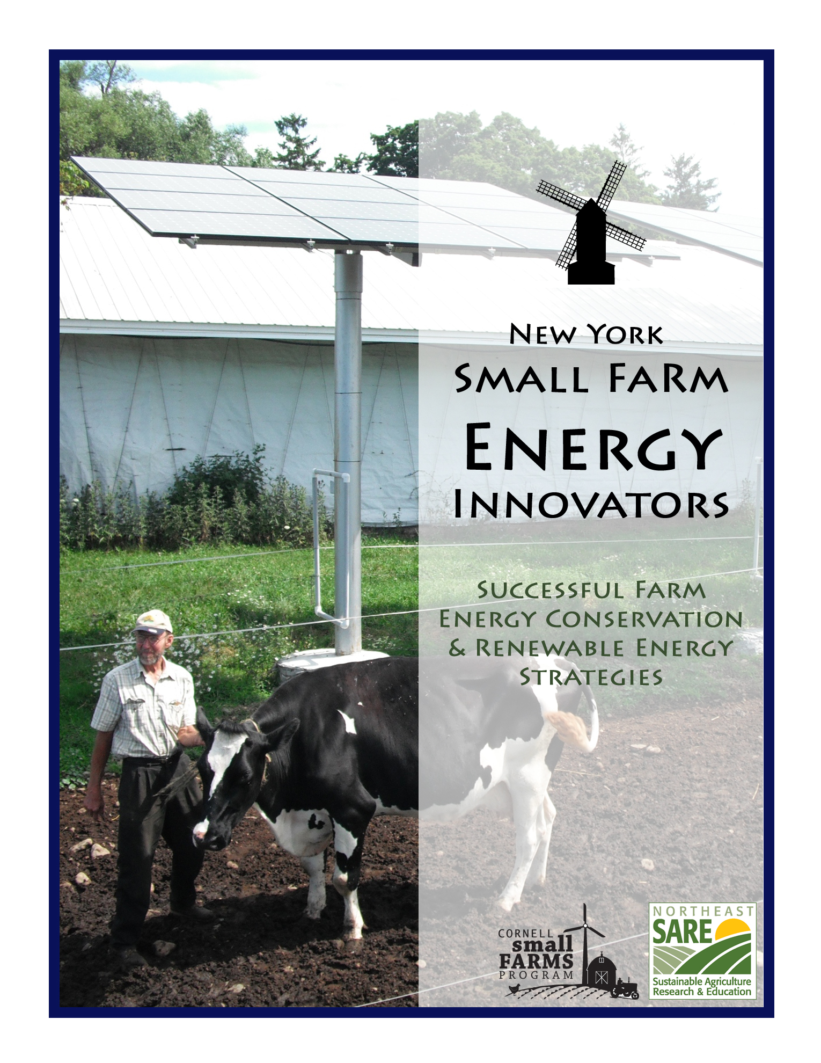

N e w Y o r k
Farm Energy Innovators
Strategies for Conserving Energy & Coverting to Renewable Fuel

Right to the Root Zone: Radiant Heated Greenhouses……………..……………..…………………. 2
Grindstone Farm – Pulaski, NY

Sun and Wind Protect the Cows from Thirst……………………………….………..……………………. 3
Barter Farm – Branchport, NY

Energy, Stewardship and Sustainability……………………………………………..………………..……. 4
Hunt Country Vineyards – Branchport, NY

Let the Sun Shine In: Making Do with Outside Power………………………..….……………………. 5
Fox Creek Farm – Schoharie, NY

Where the Green Grass Grows: Local, Renewable Fuel……………………….……………………… 6
EnviroEnergy LLC – Unadilla, NY

Fighting the Weeds with Fire and French Fry Oil…………………………..……………….…………….7
Flying Rabbit Farm – Otego, NY

About the Publisher:

The Cornell Small Farms Program (www.smallfarms.cornell.edu) works to foster the sustainability of diverse, thriving small farms that contribute to food security, healthy rural communities, and the environment. We do this by encouraging small farms-focused research and extension programs and fostering collaboration in support of small farms.

About the Authors:

Adrienne Masler was an intern with the Cornell Small Farms Program during Summer, 2009. She may be reached at amm428@cornell.edu

Annie Bass was a summer intern with the Cornell Small Farms Program during Summer, 2010. She may be reached at arb258@cornell.edu
Right to the Root Zone: Radiant Heated Greenhouses
Grindstone Farm – Pulaski, NY

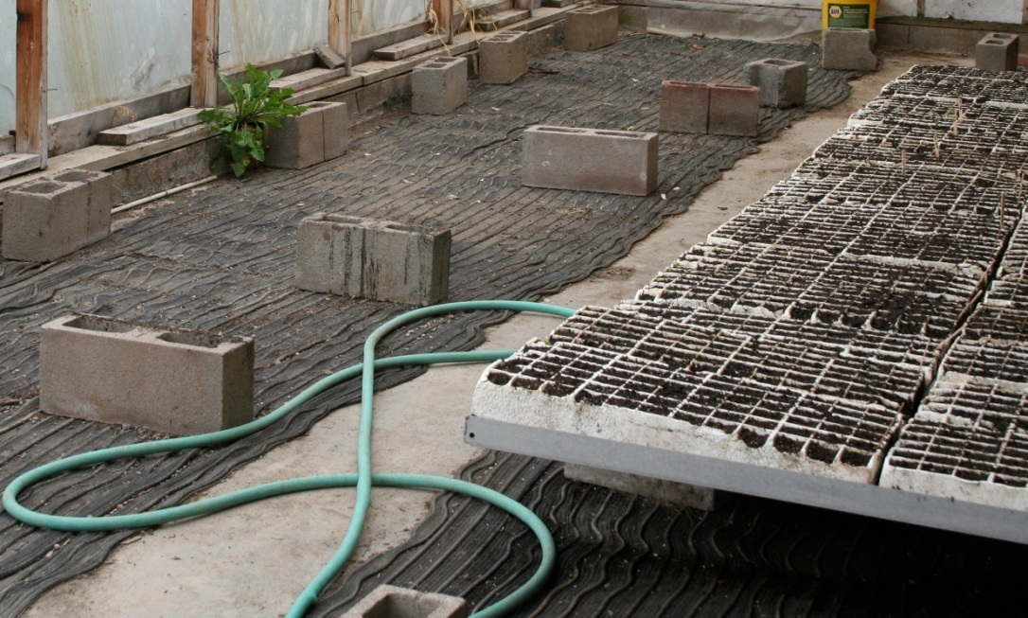
By Adrienne Masler

Four miles east of Lake Ontario, the winters are long, cold, and snowy. Finding fresh local food in the cold months might seem impossible, but Grindstone Farm sells produce year-round. Two greenhouses equipped with energy efficient heating systems have enabled Dick de Graff to sell 70% of his own produce throughout the winter season. He supplements his winter sales with purchased produce. One of Dick’s greenhouses utilizes radiant floor heat, which warms the soil for fresh salad green production all the way until Christmas. Another greenhouse makes use of germination mats on concrete which heat the rooting area only and make it possible for Dick to seed onions as early as February.
Rubber germination mats resting over concrete are connected to a 40-gallon water heater; hot water hoses alternate with hoses for transporting cooler water to the heater.

Dick started Grindstone Farm in 1981 and the farm has been certified organic by NOFA-NY since 1988. Over the years he’s transitioned from wholesale and u-pick marketing to a “healthy food box” subscription service and a CSA (customers can order produce by subscription as available without making a season-long commitment). Dick’s wife works off the farm; he hires local interns each growing season. Dick is growing on about 30 acres and has some acreage in a pasture/vegetable rotation and some in permanent pasture. The farm will produce over 200 different varieties of vegetables and fruits in 2009, along with 100 turkeys and 10 pigs.

Over the farm’s almost 30 years of operation, Dick has learned to look for ways to make his work easier without adding to his expenses. He first attempted a radiant floor greenhouse in 1996 and it worked well… until the pipes froze. The space was used as an unheated greenhouse and as storage until 2006, when Dick decided to lay rubber germination mats over the concrete. The mats are connected to a 40-gallon water heater; hot water hoses alternate with hoses for returning cooler water to the heater. Three years later, the rugged mats are holding up well. The mats can be installed in concrete, but Dick saved money and time by not retrofitting his greenhouse. He now starts seeds here beginning in late winter and stores winter squash in the fall (unheated, of course).

Another greenhouse was built in 1999 and a radiant heat system was installed about seven years ago. A wood-fired boiler sends hot water through underground pipes, keeping the soil warm. Dick can use row cover when the weather is coldest to keep his plants warm and maximize fuel efficiency. He uses this greenhouse primarily for season extension in the fall and drains the pipes after Christmas to prevent freezing. Careful digging to avoid damaging the pipes is a must.

Dick figures that Grindstone could produce greens year-round with his radiant heat systems, depending on available sunlight. What he isn’t sure of is the return on his winter fuel investment: grocery-store greens are available at lower prices than Dick can afford to charge in January and February. Lettuce was grown in the second greenhouse this winter without using the radiant system, but increasing the temperature would increase production. However, Dick hopes to extend the CSA into the winter months, which may create a viable market for Grindstone winter greens.
Though he does have some loans, Dick has made many of his capital investments out-of-pocket. He says that it took a few years to get his radiant systems going and that it’s important to focus on doing each step right and getting a return on the initial investment. He’s an advocate of radiant heat, whether in homes or in greenhouses: “If your feet are warm, the rest of you is warm,” he says.

To learn more about Grindstone Farm, visit http://www.grindstonefarm.com.

To learn more about radiant heat systems for greenhouses, visit http://attra.ncat.org/attra-pub/root zone.html.

Sun and Wind Protect the Cows from Thirst
Barter Farm – Branchport, NY
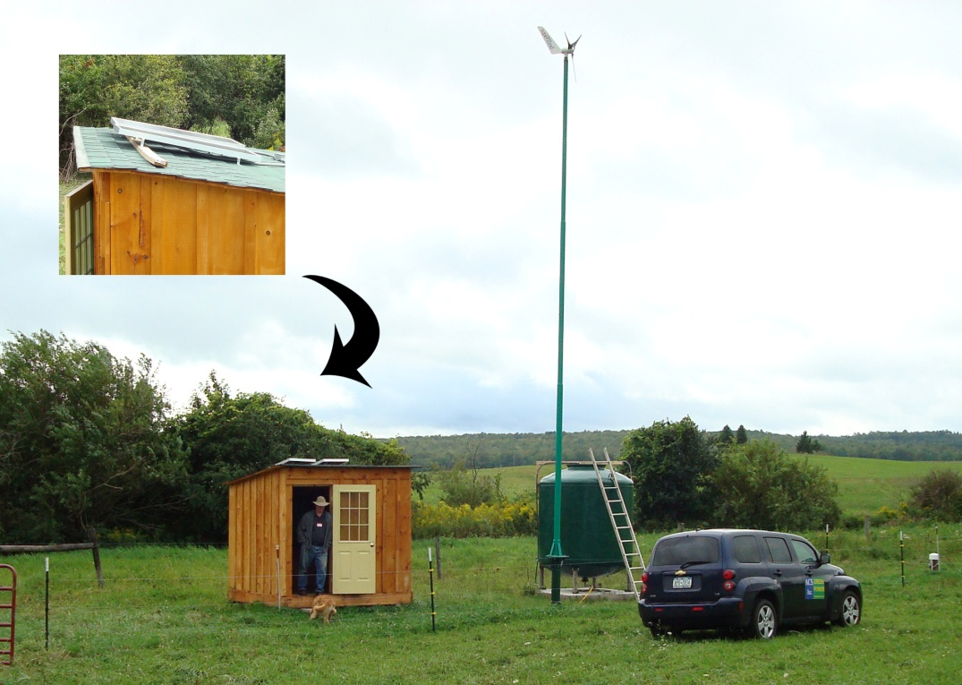
By Annie Bass

For three years, Jonathan Barter hauled water to his pastures by trailer. He didn’t have a well for his 170 cows and sheep, because wiring electricity to power a well pump is prohibitively expensive. The farm is on a plateau, precluding the possibility of a pond, a common method of providing water for animals or irrigating plants in inaccessible locations. With no other options, Jonathan hauled water across his property every few days. He often worried about whether the animals had enough to drink.

In 2008, Richard Winnett, of the Finger Lakes Resource Conservation and Development Council, was awarded a series of grants from the Natural Resource Conservation Service to offer cost-share assistance to farmers to fund solar and wind powered livestock watering pumps in remote pasture. Barter Farm enrolled in the program and initial wind speed testing reported excellent conditions. Wind was not enough, though. Sporadic, unpredictable, and low in the summer, when animals need the most water, wind was not the Barters’ ideal energy source.
After site testing, a wind turbine and solar panel combination offered the most reliable approach to keeping Jonathan’s trough filled with water.

Working with Richard and Automated Control Systems, of Rochester, NY, Jonathan designed a system dominated by a wind turbine, but also including a photovoltaic display, so that it draws on complementary power sources, harvesting energy whether the sun shines or the wind blows. The combined 500 watts power a pump, which runs at 350 watts—a built-in safety net. Two batteries store the excess output.

The cost of wind turbines pushed the project’s viability. Jonathan did some research, and decided on Super Wind, a small spire (35 feet) intended for use by the Marines. Super Wind’s manufacturer, Mariah Power, put him in touch with Automated Control Systems. Jonathan had the idea in his head, but “for this application, I couldn’t find any precedent.” He needed an engineer’s help. “[ACS] put together the components for the system to do what we wanted to do,” he says.

ACS supplied the plan and the components, and connected the turbine, panels, well, and batteries once they were all in place. Jonathan did all the installation himself—without slowing down work on the farm. The well was dug in November of 2009, but installation didn’t start until May of 2010, and didn’t end until July. “It was a very hectic time, trying to make hay,” he said, just days after finishing. “I’m very happy it’s over now.”

Since embarking on the project, Jonathan has recruited 6 other farmers to take advantage of the RC&D funding. Renewable energy was the most practical solution for his situation, but even with the grant assistance, his personal bill was still hefty. “I can’t imagine somebody investing the money out of pocket,” he said. Energy costs are especially burdensome for small farmers, says Jonathan, because they are more likely to raise exclusively grass-fed animals in remote locations, driving up both the utility and the cost of projects like his.

The pump is set to fill not only the trough, but also an above-ground storage tank that refills the trough went levels get low. The tank stores four days’ water—a grace period longer than the entire watering cycle back in the days of the trailer. When asked how the use of renewable energy has changed his farming, Jonathan said earnestly, “I don’t have to worry about whether the cows are going to run out of water or not.”

For more info: www.fingerlakesrcd.org

Energy, Stewardship and Sustainability
Hunt Country Vineyards – Branchport, NY

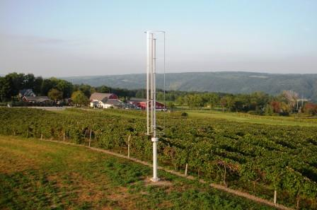
By Adrienne Masler
As sixth-generation stewards of their Branchport, NY land, the Hunt family is invested in doing what it takes to care for their land. Their interest in stewardship and sustainability go hand-in-hand with their interest in saving money and energy self-sufficiency – “So we can still operate when the power goes out,” says Art Hunt. Many of their strategies result in net energy savings, even those that seemingly have little to do with energy. For example, encouraging bats to live on the farm helps to keep the insect population down – which means that the Hunts spend less money, time, and fuel on pesticide application. When they do spray, their tractors are powered with biodiesel, thanks to used cooking oil from local restaurants. The Hunts have paid close attention to energy conservation throughout their facilities expansion, especially insulation, and are considering the use of thermal pumps to heat and cool their buildings. Further reductions in electricity costs will be achieved with the use of renewable energy technologies: installation of a vertical wind turbine is underway in the summer of 2009.
The turbine will generate up to 1.2 kW of electricity, about 2000 kW hours per year

Vertical wind turbines are designed to work at slower wind speeds than propeller turbines. The Hunts are working with Nevada company Mariah Wind to install the turbine as a demonstrator. The turbine will generate up to 1.2 kW of electricity – about 2000 kW hours per year – which is enough to meet one quarter of the annual energy needs of the average American home. The farm’s electricity usage is about 15 kW per hour, so they aren’t expecting a significant impact on their electric bill from the 1.2 kW turbine. However, if this turbine meets its rated capacity and productivity, it will be replaced with a higher-capacity turbine.
The turbine will be connected to the farm’s existing circuitry and the electricity will be used to offset the power purchased from the utility company. Hunt Country is undertaking this venture without an external source of funding because the New York State Energy Research and Development Authority (NYSERDA) has not yet approved Mariah Power turbines; the cost to purchase and install the turbine is $6000. NYSERDA approval of Mariah Power’s turbines is contingent on the company’s submission of the results of government tests, which were favorable.

Determining how much money the Hunts have saved through their efforts is difficult because their energy usage has changed dramatically over the years, but one example illustrates the dramatic difference that smart energy use can make. As the winery’s facilities expanded, their tanks were moved outside, where they needed to be heated in the winter and cooled in the summer. The tanks got a new building in 2008, and simply creating a more controlled environment saved the Hunts about $1000-$2000 in heating costs over the winter – about 10% of their costs the previous winter. Those savings aren’t enough to satisfy Art, who believes that they could save $8000 with better planning. “We use way too much electricity and propane right now,” he says, because wine tanks and buildings often require heating and cooling at different times. As part of the farm’s energy strategy the Hunts are
investigating the possibility of installing heat pumps, which transfer heat from
the ground or the air to where it is needed (or vice versa) instead of generating more heat.

To learn more about Hunt Country Vineyards, visit www.huntcountryvineyards.com.

To learn more about Mariah Power, visit http://www.mariahpower.com and http://windspire.info.

Let the Sun Shine In: Making Do with Outside Power
Fox Creek Farm – Schoharie, NY
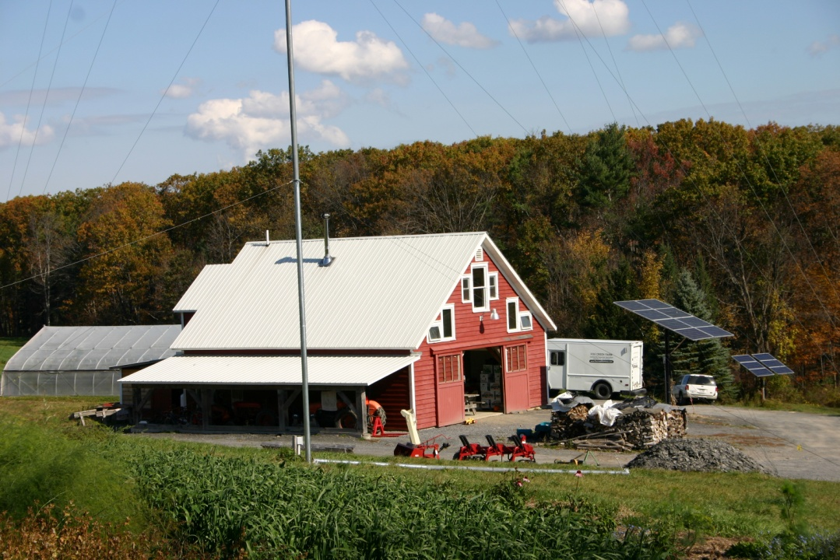
By Annie Bass

Seven years ago, Sara and Raymond Luhrman began farming on rented land, serving ten members in a Community Supported Agriculture model (CSA). Two years later, they were up to forty members and had outgrown their land. They had started farming as a hobby, and with such a big operation, it had outgrown its place in their lives, too; they had to decide whether to scale back or go all-out. “So I quit my day job,” Raymond says.

Five years after the move, the Luhrmans serve 200 CSA members at Fox Creek Farm, and they do it without a connection to the national grid. When they bought the land, which adjoins their original rented site, they were faced with the decision of whether to spend the $40,000 to get electricity in, or to try to swing it without the grid’s safety net.
To keep costs down, the Luhrmans installed the wind turbine and solar panels themselves.

They opted for self-sufficiency, installing a 1 kW photovoltaic solar array and 100-foot wind turbine. Along with installing the means of production, the Luhrmans paid attention to minimizing their energy needs, selecting a high-efficiency well pump and heavily insulated cooler for storing the vegetable harvest until delivery. They built their house, the first floor of which is a barn, according to the principles of passive solar design: south facing, super-insulated, and with opportunities for cross-ventilation to lower summer temperatures.

Without a connection to the grid, government subsidies and incentives disappear. Raymond and Sara had to finance their own energy entirely. To keep costs down, they installed the turbine and panels themselves. Raymond says some understanding of electrical installation work is needed, but neither Raymond nor Sara is trained in the area. They ordered catalogs from off-grid solar and wind suppliers to learn “what kind of questions to ask when you start to design the system,” Raymond says. Next they found manufacturers and suppliers (the Alternative Energy Store in Massachusetts and Backwoods Solar in Idaho), and asked them questions. Once they had ordered their supplies (Evergreen panels, Outback inverter and charge controller, and a Bergey turbine and tower), they made use of the components’ detailed installation instructions.

Site testing was as expensive as the actual installation, so the Luhrmans consulted online wind maps and found the sunniest spot near the barn to determine locations. They also visited off-grid family homes, to see full systems in operation. One of the challenges was sizing the system correctly. Using their budget as a guide, they made a guess, and in Spring, 2010, they added another .3 kW to their photovoltaic array. The total cost of both the wind and solar installations came to $20,000, half of the initial cost of connecting to the grid.

Without the grid to fall back on during cloudy, still days, the Luhrmans have to watch their energy consumption carefully. “It makes you very aware of how much energy you use,” Raymond said. “Not like an abstract number in a dollar amount at the end of the month when the bill gets sent to you by your energy company.” After producing their own energy continuously for four years, the Luhrmans have figures at the ready: they use 8 to 9 kW a day during the farming season, and less during the rest of the year, when the cooler is off.

“The biggest drawback,” Raymond mused, “is if we were to get into a value-added operation like freezing, for example … that would take another couple solar arrays. On the other hand, the size the farm is, we make a living off the operation. It’s a good match.”

To learn more about Fox Creek Farm, visit www.foxcreekfarmcsa.com.
Where the Green Grass Grows: Local, Renewable Fuel
EnviroEnergy LLC – Unadilla, NY

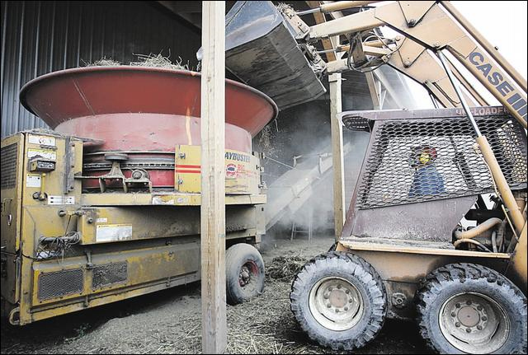
By Adrienne Masler
Loading hay into the shredder

A lifelong interest in “green” energy, high fuel prices, and Delaware County’s increase in non-farming landowners created an opportunity for May and Bob Miller to embark on a new business venture: making grass pellets. Approximately the size of grain pellets (~1/8” in diameter and ~1/2” long), grass pellets can be burned in stoves to provide heat or electricity. While researching grass pellets, the Millers traveled to Canada because they had heard that it was feasible to pellet grass there. They learned that no one was making pellets for local home energy use: Canadian pellets were marketed for horse bedding or for coal plants. The Millers continued to research the pellet industry in the United States, paying attention to what was working and what wasn’t working. “We thought we could see where it could be done better,” says May, so they bought some old wood pelleting equipment and began experimenting. In partnership with their son, May and Bob created EnviroEnergy LLC in the summer of 2008.

The learning curve turned out to be much longer and steeper than the Millers anticipated. For example, they had to figure out how to make dense enough pellets and what moisture content their raw material should have. They’ve received great support from Cornell Cooperative Extension in Delaware County, which received funding to install pellet stoves about the same time that Millers began pelleting grass. Other support has come from the Delaware and Otsego County Offices of Economic Development. After many rounds of trial and error, EnviroEnergy has been making successful pellets since early 2009.

Pelleting grass has turned out to be a perfect enterprise for these independent-minded retired dairy farmers. Delaware County’s newest crop of residents is largely composed of people from downstate who often hire farmers to mow their fields rather than allow them to become overgrown. EnviroEnergy can purchase this grass – they pay $60/ton for delivered hay – and make pellets. They plan to keep the business operating within a 40-50 mile radius because they enjoy working with local farmers and developing local markets for their pellets. May says that because of the available grass, high fuel prices, and increasing interest in sustainability, “this is a very good product for this area.”

All of the pellets made since the Millers began pelleting have been sold and used successfully, but there’s a lot of room for growth. Grass pellets have a higher ash content than their wood counterparts, and while some wood pellet stoves can burn grass pellets, some can’t. May and Bob keep track of which stoves work for their customers and recommend contacting Cornell researcher Dr. Jerry Cherney for more information about pellet-burning stoves. As stoves designed to burn grass become available, the market for grass pellets will improve. May thinks that pelleted grass is a good fuel alternative in the Northeast: there’s ample opportunity for local pelleting businesses and grass pellets produce 90% less emissions than allowed by the EPA.

Though the Millers are focused on making pellets that burn well, some customers are coming up with alternative uses. Some use grass pellets for cat litter or horse bedding and love the product’s absorbency. A nursery tried and failed to germinate weed seeds in the pellet material and may explore using pellets as mulch or in a potting soil mix. Whatever the application, the Millers are committed to producing a quality product.

Learn more about Enviroenergy at www.enviroenergyny.com

Fighting the Weeds with Fire and French Fry Oil
Flying Rabbit Farm – Otego, NY
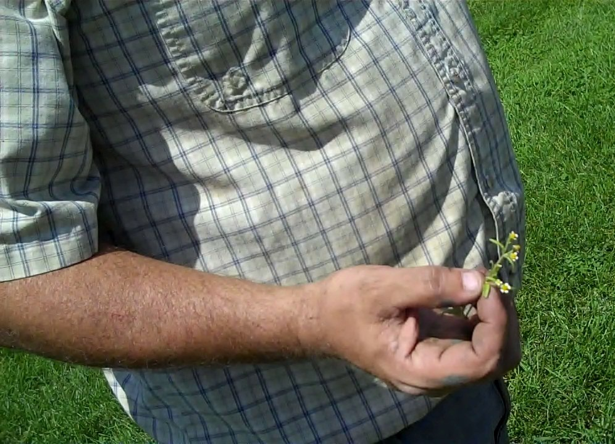
By Annie Bass

In 2006, Flying Rabbit Farm was under water. “We rode the canoe up over the railroad tracks,” Dave Dolan said. “Your head would’ve been under water.” Not to mention the rows of wheat and kale on either side of us.

Dave and Mary Dolan have been farming this land for seven years, in a small-scale organic operation that includes collards, kale, chard, and baby lettuce mix for wholesale, and a wide variety of offerings, including tomatoes, corn, and chicken eggs, for the family and their neighbors. After 20 years of farming in three locations, they’ve worked out most of the kinks. They used to sell directly at a New York City Green Market, but with two part-time jobs, one child, and environmental concerns about mileage, they’ve switched to wholesale, with restaurants near the farm in Otego, NY, and with Regional Access in Ithaca, NY. Nieces and nephews provide seasonal help such as weeding and harvesting. And they’ve got the baby lettuce system down to a science, with Mary harvesting and Dave washing, weighing, and packaging.
Galinsoga is Flying Rabbit Farm’s most problematic weed.

Their main challenge is weeds. Dave picked a sprig of small white and yellow flowers from the edge of one of the rows. Galinsoga, Flying Rabbit’s most problematic weed, is a perennial that seeded itself among their crops for the first time in the 2006 flood. “See all these little flowers?” Dave said. “Each one has 4,000 seeds in it.”

“Other organic farms, that aren’t in floodplains, maybe it’s not such a problem for them,” Mary said. But since 2006, Flying Rabbit Farm has had to contend with “all the weed seed in the county.” They plant both fall and summer cover crops whenever possible to combat the weeds. But with 30 hours spent working off the farm each week, Mary and Dave don’t have time to hand-weed, mulch, or direct-seed into compost above the soil. Their commitment to sustainable practices, even before they sought organic certification, ruled out chemical options. Row cover, put down to thwart flea beetles, increases the temperature in their arugula beds so that the plants germinate faster than the weeds—but row cover is impractical or ineffective for most of their greens and row crops. And with the baby lettuce mix, their primary crop, harvesting takes twice as long in a weed-filled bed as in a clean one.

With baby lettuce’s three week growing cycle, flame weeding is an attractive technique. After the beds are prepared, before planting, a flame weeder can turn the young weeds to ash, killing them without disturbing the soil, which would cause more weed seeds to germinate. Mary could then direct-seed into the ash. The Dolans wanted to implement this method, after applying compost and letting the beds lie fallow for the winter. In past years they’d tilled to create a dust mulch, which didn’t work in wet years. With flame weeding, they could better preserve soil structure with repeat shallow cultivation to germinate and kill weeds successively, until the scorch right before planting.

But flame weeders run on propane, and the Dolans are committed to environmental sustainability. They run all of their farm equipment on waste oil, mostly from a tank of second-hand French fry oil, though neighbors contribute their used cooking oil as well. Their house and greenhouse are heated by a biomass boiler, for which they grow their own wheat. The barn roof is covered in photovoltaic panels, and a solar thermal installation supplements the boiler in heating the waste oil before use, so it burns cleaner. They used to use grass pellets to fuel the boiler, but found that wheat is significantly cheaper. “I’m torn about
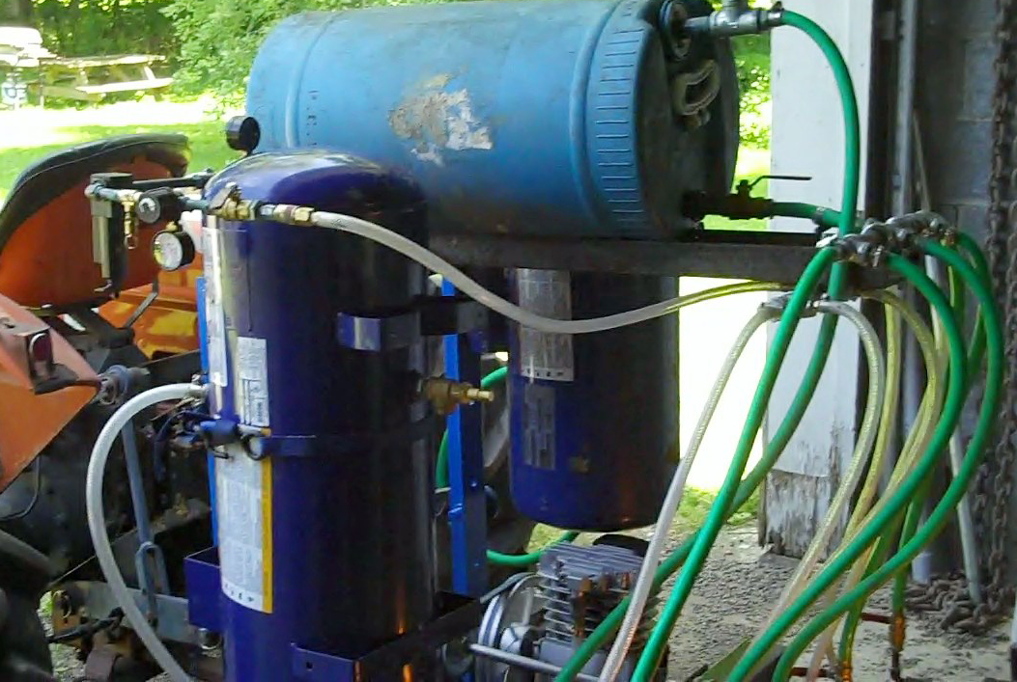
using the grain,” Dave said. “Economically it’s smarter to, but something about it just rubs me the wrong way. You know, the whole food for fuel thing.”

They had the waste oil operation set up already, if they could just use waste oil instead of propane as fuel. In 2010, Northeast SARE (Sustainable Agriculture Research and Education) awarded the Dolans a farmer grant to figure out how.

By July, the machine sat in the Dolans’ barn, hooked up to the tractor. It had come a long way, with the original alternator and compressor replaced by mechanical pumps and pulleys, but there was tweaking yet to go. “I blew the budget on a couple of the big electric things, and now we’re not even using them,” Dave said. But he’s optimistic about the project—and for good reason.
Dolan redesigned his flame weeder to fun efficiently on waste vegetable oil.

He got into the tractor seat, turned the key, and twisted back to watch the flames spurt out.

After the demonstration, Dave asked if I could think of any improvements. I said this was the first flame weeder I’d seen. “Me too,” he said.

A combination of thorough research and ingenuity has allowed Dave and his nephew, Adam, to build a unique and effective model. Standard oil burner furnace guns gum up when used with straight vegetable oil, so the waste oil flame weeder is equipped instead with Babington ball nozzles, which receive separate inputs of oil and pressurized air. In addition to facilitating a steady flame, the separation of the airflow reduces the weeder’s explosive potential. Five Babington balls line a height-adjustable metal strip, which is perforated throughout so that the nozzles can be set to variable width and distance. A shield affixed on top will guide the flames downward to the soil.

The Dolans hope to spread this new technology among organic farmers who “tend to shy away from intensive use of fossil fuels” such as propane-fueled flame weeders. They’re planning articles with Farm Catskills, a field day at Flying Rabbit, and other events.

Ultimately, the flame weeder is one of a series of experiments for Dave, and there’s always a next project. Across the tracks from the house and main field, Dave surveyed the rows of rye he’d left in through the summer. With the flame weeder up and running next year, his vision is to sow the whole rest of the farm like this. “The Bible says to let your land rest every seven years,” he said. “I want to try that, just doing the baby salad beds. We make more money on that amount of salad greens than I could fiddling around with acres of tomatoes.”

For more energy resources, including an electronic version of this publication, visit www.smallfarms.cornell.edu/pages/resources/production/energy.cfm

