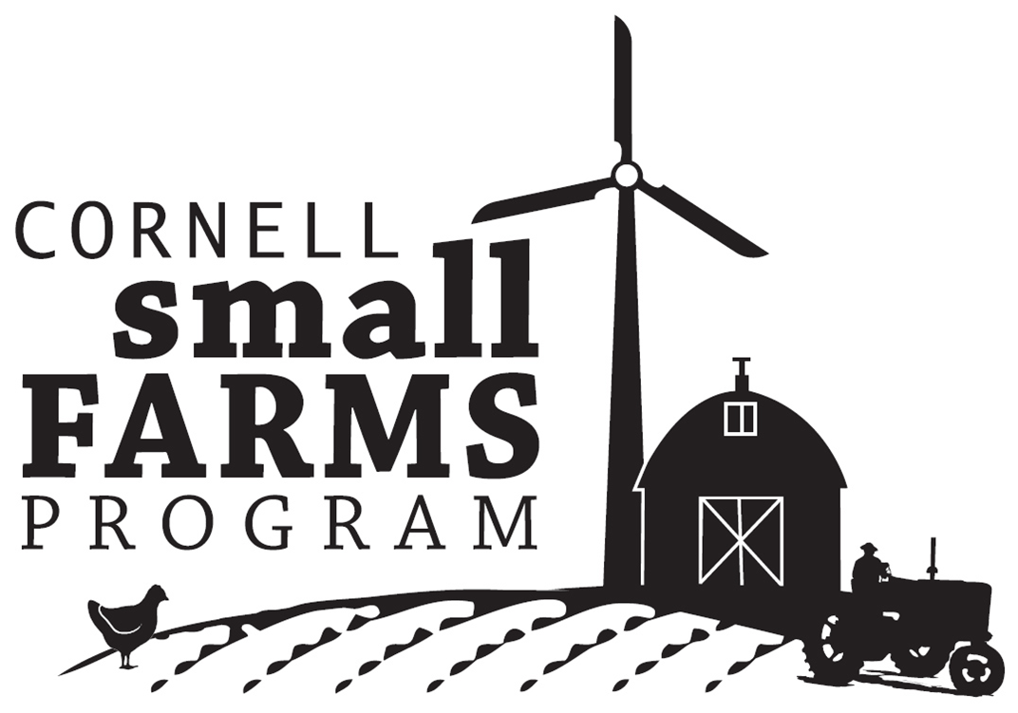 | Emerging Opportunities to Enhance Viability and Support of Small Farms in New York  (in order of priority, based upon 73 responses)

CAPITAL DISTRICT results

- Develop food distribution strategies (e.g. collaborative marketing, product pooling and trucking, food hubs) to expand small farm access to local and regional markets
- Document economic impact of small farms on their communities to increase investment in and support of small farms
- Develop new and/or expand existing livestock processing facilities
- Advocate for greater investment in small farm services (i.e. research, extension and education)
- Develop and promote affordable energy conservation and renewable energy sources for small farms
- Identify alternative financing strategies accessible to small farms
- Evaluate livestock processing regulations and policy for impact on small farms
- Conduct trainings on alternative livestock production and marketing strategies to overcome processing bottlenecks
- Develop strategies to expand on agricultural land access
- Evaluate and promote profitable value-added processing of milk (e.g. yogurt, cheese) to expand market opportunities for small dairies
- Expand grazing education and research
- Conduct research and education on food safety risks of small farms
- Expand support for small farms producing in urban areas
- RECRUIT youth, minorities, and military veterans into farming
- Expand production and processing of local biomass and biofuels for small farms
- Identify novel technologies/practices to improve viability of small dairy FLUID milk production

