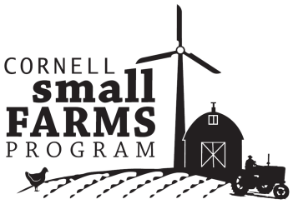 | 2012 NY Small Farms Summit  Emerging Opportunities to Enhance  Viability and Support  of Small Farms in New York
Agenda
February 29th 2012
9:15 am Registration
9:45 am Welcome - Anu Rangarajan, Director- Cornell Small Farm Program
10:00 am 2011 Investments: Supporting Local Markets
    - Becca Jablonski, Dept. of City and Regional Planning, Cornell
    - Matt LeRoux, Cornell Cooperative Extension of Tompkins Co.
10:30 am Dean Katherine Boor- CALS Commitment to Small Farms
11:00 am A Vision for the Future of Small Farms in NY- Two Farmers’ Perspectives
    - Katie Carpenter, Plato Brook Farm, Arcade, NY
    - Jim Hayes, Sap Bush Hollow Farm, Warnerville, NY
11:30 am Prioritizing Opportunities to Enhance Viability and Support of Small Farms
12:00 pm Lunch and Networking
1:00 pm Workshop 1: Review and amend Small Farm Priorities by region
1:45 pm Workshop 2: Clarify regional approaches to enhance support for small farms
3:00 pm Priorities for Small Farm Support- Ideas from the regions
3:30 pm Evaluation and Adjourn

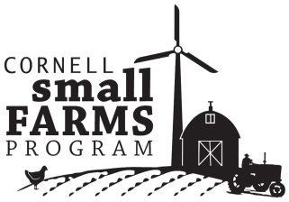 | Emerging Opportunities to Enhance Viability and Support of Small Farms in New York  (in order of priority based upon 360 responses)

STATEWIDE RESULTS
- Develop food distribution strategies (e.g. collaborative marketing, product pooling and trucking, food hubs) to expand small farm access to local and regional markets
- Document economic impact of small farms on their communities to increase investment in and support of small farms
- Develop new and/or expand existing livestock processing facilities
- Identify alternative financing strategies accessible to small farms
- Advocate for greater investment in small farm services (i.e. research, extension and education)
- Develop and promote affordable energy conservation and renewable energy sources for small farms
- Evaluate livestock processing regulations and policy for impact on small farms
- Evaluate and promote profitable value-added processing of milk (e.g. yogurt, cheese) to expand market opportunities for small dairies
- Conduct trainings on alternative livestock production and marketing strategies to overcome processing bottlenecks
- Develop strategies to expand on agricultural land access
- Expand grazing education and research
- RECRUIT youth, minorities, and military veterans into farming
- Expand support for small farms producing in urban areas
- Conduct research and education on food safety risks of small farms
- Expand production/processing of local biomass and biofuels for small farm
- Identify novel technologies/practices to improve viability of small dairy FLUID milk production

OTHER SUGGESTED OPPORTUNITIES
Develop REGIONAL FOOD PROCESSING FACILITIES for small producers
Address TAX ISSUES for small farms
Address SMALL FARM INSURANCE/RISK MANAGEMENT
Address LABOR CONCERNS ON SMALL FARMS
Explore strategies for IMPROVING ACCESS TO AGRICULTURAL INPUTS

